.COURSE BCE

**NGO Project**

Child Vision Foundation

horizontal line

# 

# 

# 

# 

# 

# 

# Introduction

**Child Vision Foundation**

Website :- <https://www.childvisionfoundation.org/>

Child Vision Foundation ( CVF ) is a registered non-political, non-profit secular NGO based in Mumbai working on the issue of Complete Child Care with a team of dedicated and skilled professionals since the year 2013. CVF has reached out to over 10,000 children and adults directly and over 30,000.00 individuals indirectly since its inception.

CVF is currently working from Mumbai in Maharashtra with a child centric model of intervention in the area of Complete Child Care (CCC) with a balanced emphasis on prevention and healing components

**Mission :**

* To work towards creating a better India which provides basic health, education and empowerment to every citizen
* To be a Knowledge/ Execution Partner of Schools, NGOs, Corporate, and Government agencies for development programmes across India.
* Building capacity of education NGOs to achieve sustainability & scalability, thereby enabling delivery of quality education.

**Vision :**

Child’s vision is to be the primary support and platform for a civil society represented by a global community of informed, empowered and committed NGOs that fully participate with the UN in decision-making and programs leading to a better world, a world of economic and social justice.

**They Work For :**

* Heart Care
* Girl shield support
* Education Support
* Orphan Support
* Rehabilitation Centers

**Awards:**

CVF has 2 International and 3 National awards

* Global NGO Excellence Award in 2016 for the Health sector.
* ABP CSR Leadership Award in Feb 2017 For Education sector improvement.

## Day 1 : Aug 13, 2022 11:00 to 4:00 [4hrs]

On the first day we were given an introduction about child vision foundation works, mission and vision of this NGO. to understand this we were asked to go through their brochure , pamphlets and visit the website. How this NGO functions also was given an introduction about their team and current project they are working on and how we as a volunteer can make change in this initiative.

Introduction was headed by the ngo’s resource manager ‘Manikandan’ sir and he also shared this story with us about how he reached this position as a handicap plus orphan . He studied till 8 th grade but knows 10 different languages and is fluent in all languages. Also he has done dance choreography in many national tv programs such as DID and worked with many big choreographers. How experiences change man was also well defined by his words.

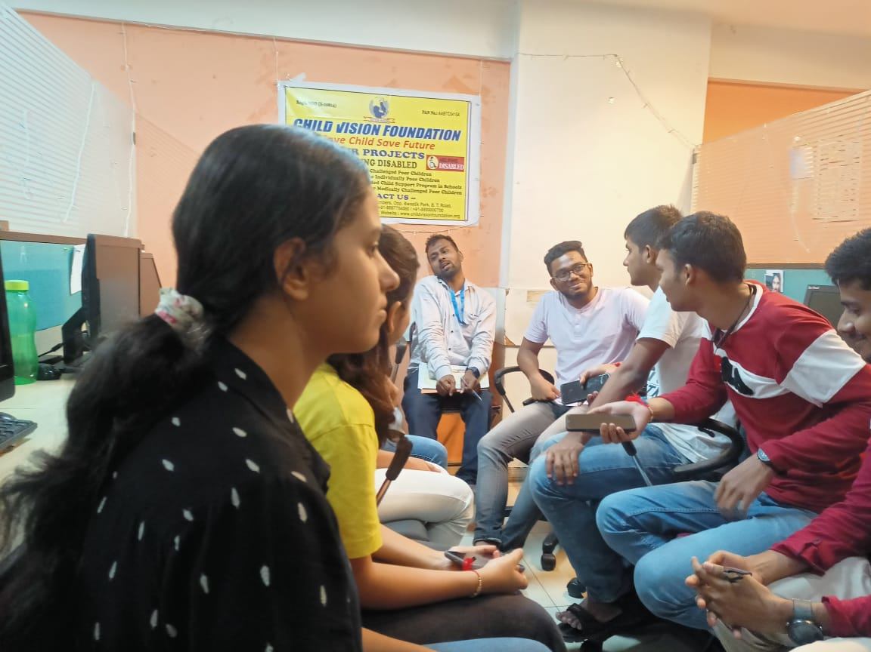

We were told about time importance and why and what is the real reason for college asking us to connect to some NGO.Project is regarding arranging event hosts for handicaps. And how we can contribute regarding work.

Why we are there for ngo and what are the steps and basic understanding before we join ngo this is what our ngo resource manager wanted to see within us.They generated the need and meaning and also asked to have selflessness and a positive attitude towards what we work .

Teamwork is the most important part of our job. I also understood why we need ngo in our society. We helped them pick up ration bags that we will distribute on independence day to the needy people as from here on our true work towards ngo begins.

Sahil Parab (left) and Mayur Pimpude ( right) Sahil Parab (left) and Satyam Dubey (right)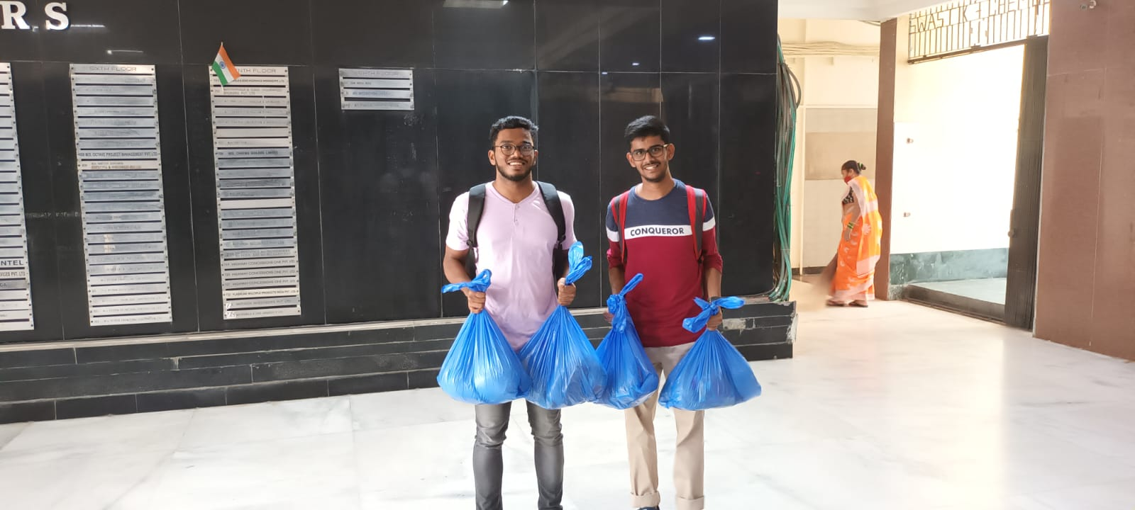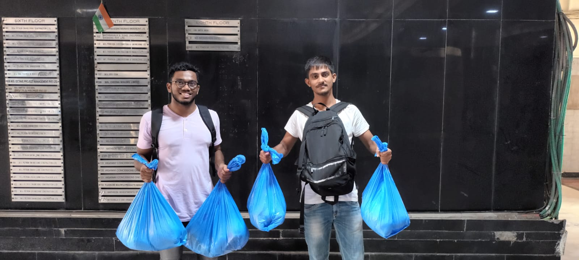

Day ends with the NGO General manager having a word with us regarding how we can understand and identify society’s problems and importance, how to approach solutions to the problem and to be one true human and the importance of resources - how these only few resources for us are a big help to the true needy.

## 

## Day 2 : Aug 15, 2022 8:30 to 11.00 [2.5 Hrs]

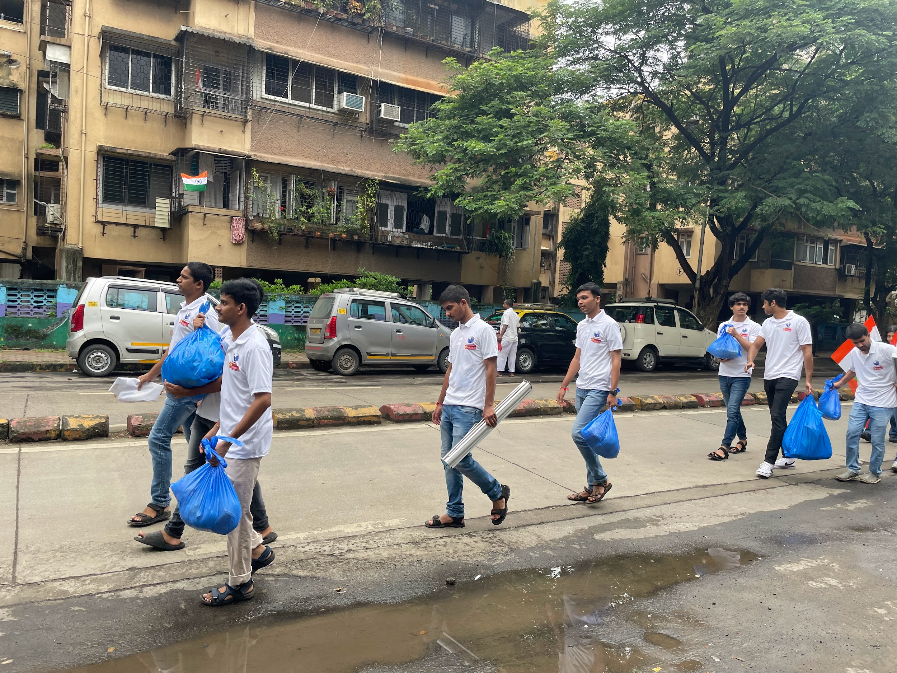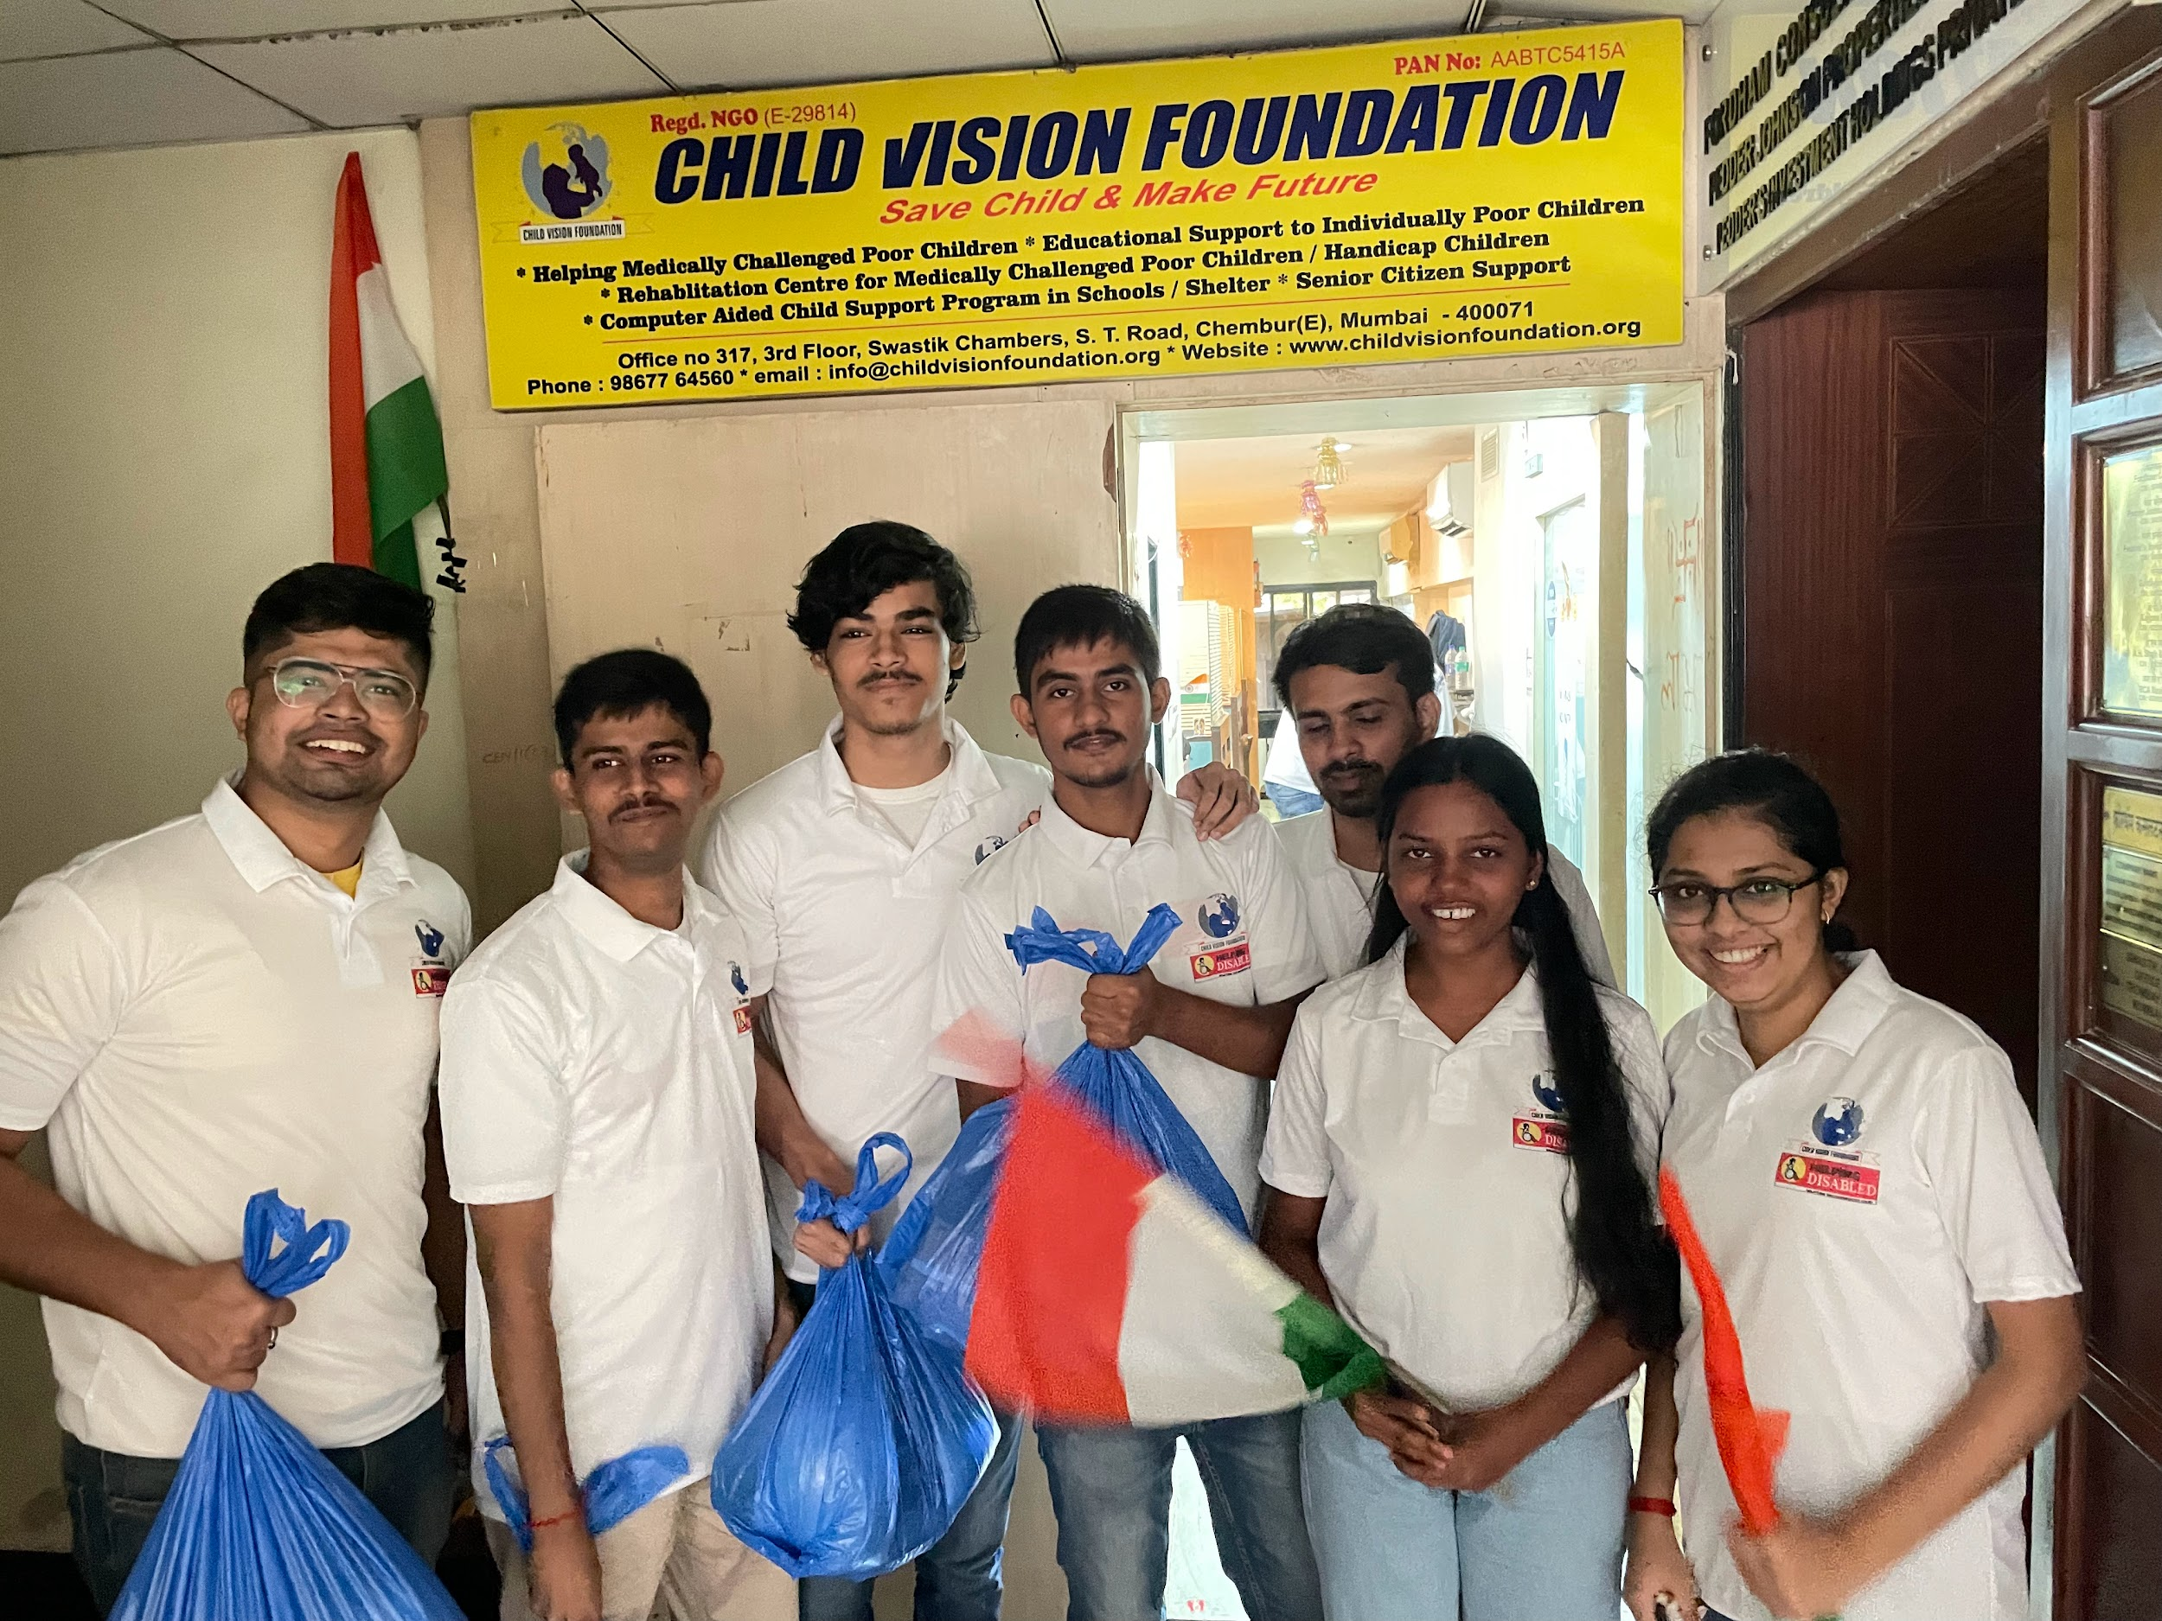

The start of Day two was the onset of our first field service at Jai Himgiri Society, Swastik Park, Chembur, which was an epicenter of a widespread slum in that area. Our Day started by collecting ration bags, Eatables, and our National Flag from the head office of our NGO. We Carried our Enthusiasm with great pride walking on the streets with our tricolor flag toward our destination which was about three kilometers away, meanwhile helping the people who need our help in the nearby areas, by providing them with one day's ration.

We reached our destination sharp at 9.00 AM, as the flag hosting event was going to start by 9:30 AM. We were welcomed with a round of applause by all the members in the chawl, this was a very eternal moment for all of us, and it pumped us to work even more than what we had expected before reaching our destination.

We started putting our banner, placard, and our national flag for the flag hosting event. Meanwhile the guest Mr. Sanjay Pandey arrived, looking at our preparation and our willingness to help, he felicitated our manager Mr. Kumar Abhinav, and us with a bouquet and a shawl.

Since it was the “Azadi ka Amrit Mahotsav” we distributed the tricolor flag to every child in the locality and soon we all stood for the national anthem. After which we started volunteering for the snacks distribution for small children and then the adults in the chawl.

This event was a true eye-opener for us, which not just taught us about how to successfully organize an event but, what are the needs of the people who belong to the category of lower Income Class. This event gave us a lesson that there are people who need our help and we must give back to society some of the learning we have done, more than earning our first lakh and crore which our case might be.

**Day 3 : Aug 18, 2022** **3:30pm to 5:30pm [2 Hrs]**

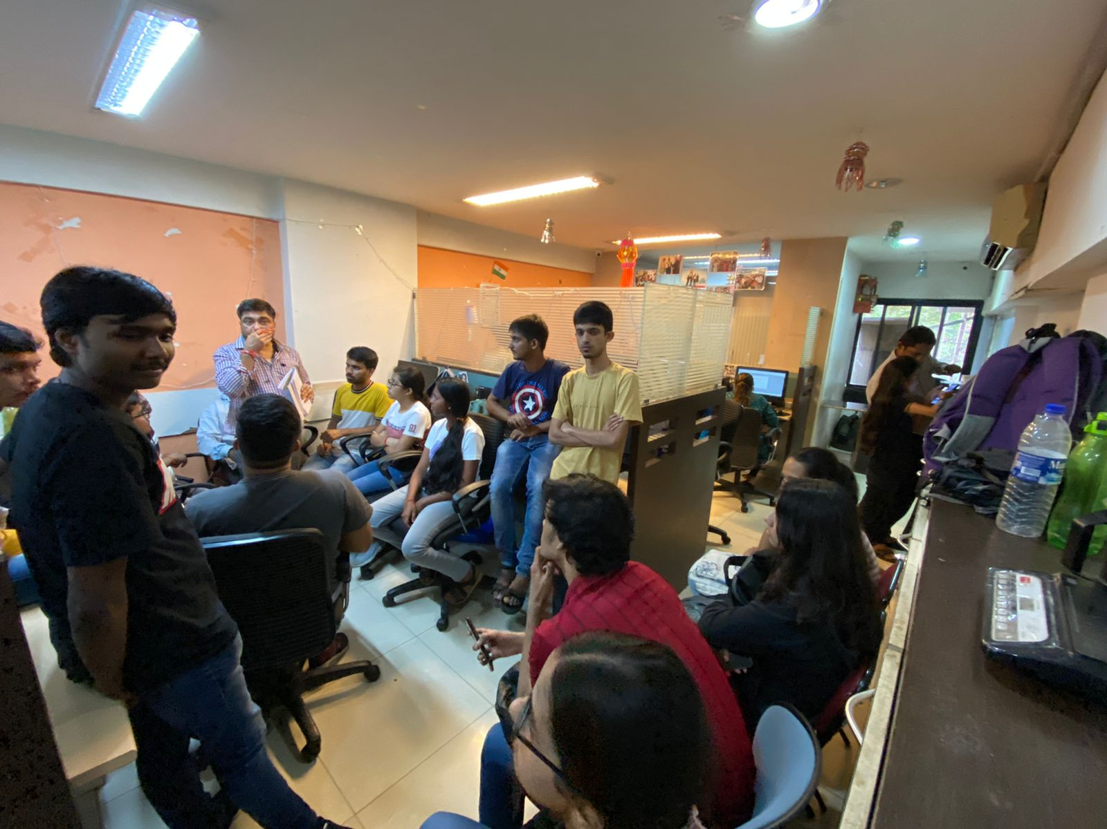

The third day at NGO was a meeting held for planning and preparation for the event “HELPING DISABLED” which was organized on Aug 20th with the vision of Helping differently abled and needy with Equipments and Assistive devices. It was going to be a grand event with an approximate of 200 beneficiaries getting aided. The event was basically a distribution programme of Equipments and Assistive devices which was to be initiated by ‘Deep Prajwalan’ and continued by entertainment program, distribution to the beneficiaries and snacks distribution.

The workflow of the event was discussed along with the venue. The list of people attending the event included Chief Guests, VIP’s, Beneficiaries and their family members, volunteers and the NGO management staff. We were assigned with our responsibilities and tasks as a volunteer with the position and places to be handled and managed at the venue on the day of the event as it was going to be a day long event.

We learnt not only how to plan an event which was going to be held on a large scale but also made us think on how to look at different aspects of the event, what’s the importance of preparation and planning, thinking of all the problems that can occur in the first place and have a proper backup plan for every situation and most importantly getting prepared for the worst and tackle problems on ground reality.

## Day 4 : Aug 21, 2022 10:30 to 7.30 [8 Hrs]

The highly anticipated event of our NGO, 'Helping Disabled,' to aid differently-abled people with assistive equipment like a blind stick, hearing aid, wheelchair, tricycle, and axillary crutches took place on the fourth day.

We reached the venue, Zaverben Popatlal Sabhagraha Auditorium, Ghatkopar, at 11:00 A.M. to foresee the seating arrangement of the guests and the beneficiaries and set the pieces of assistive equipment up for display. Our fellow team members then proceeded to their allocated positions. Few volunteers were put on duty at the Ghatkopar railway station in case the visually impaired or other invitees faced problems locating the venue. The beneficiaries had begun to arrive and were personally led inside the venue by our team and provided tokens. The tokens were distributed on the spot according to the seating arrangement. Volunteers inside the hall directed the beneficiaries to their respective seats according to the token provided. As some of the beneficiaries wished to be seated with their kin, we were able to coordinate through the last moment changes in a hassle-free manner.

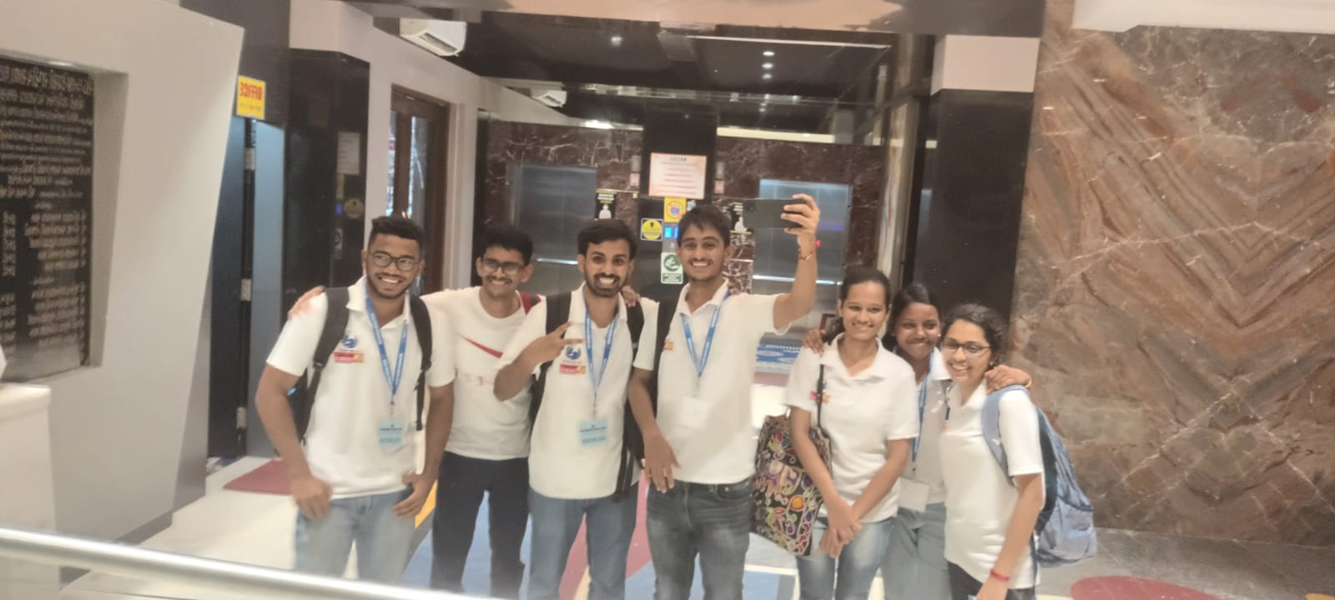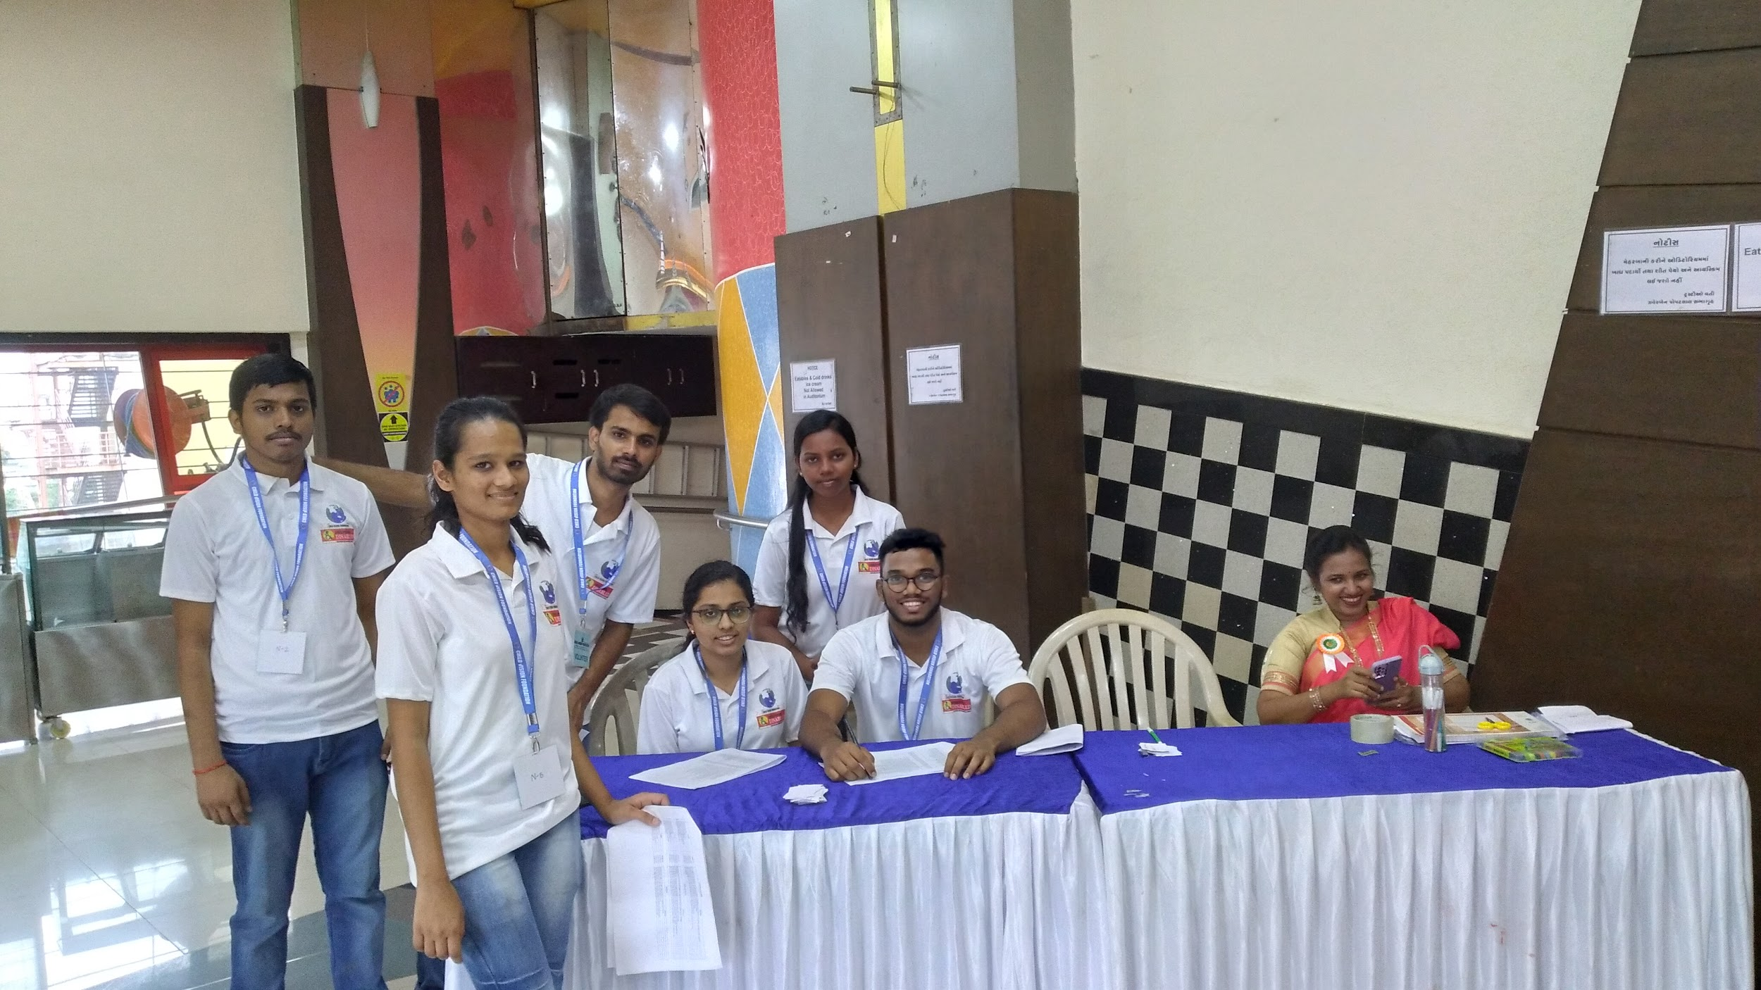

Our manager and fellow team members gave the chief guests a warm welcome.

The inaugural function commenced at 3:00 P.M. with the lighting of the lamp by the chief guests and the other dignitaries, followed by the National Anthem. Beneficiaries were then escorted to the stage and presented their respective equipment by the chief guests. Various performers and the staff of our NGO enthralled the audience with their spectacular dance and singing performances. Mr. Kumar Abhinav (manager of NGO) delivered the vote of thanks. We then distributed snacks and water to everyone in the venue.

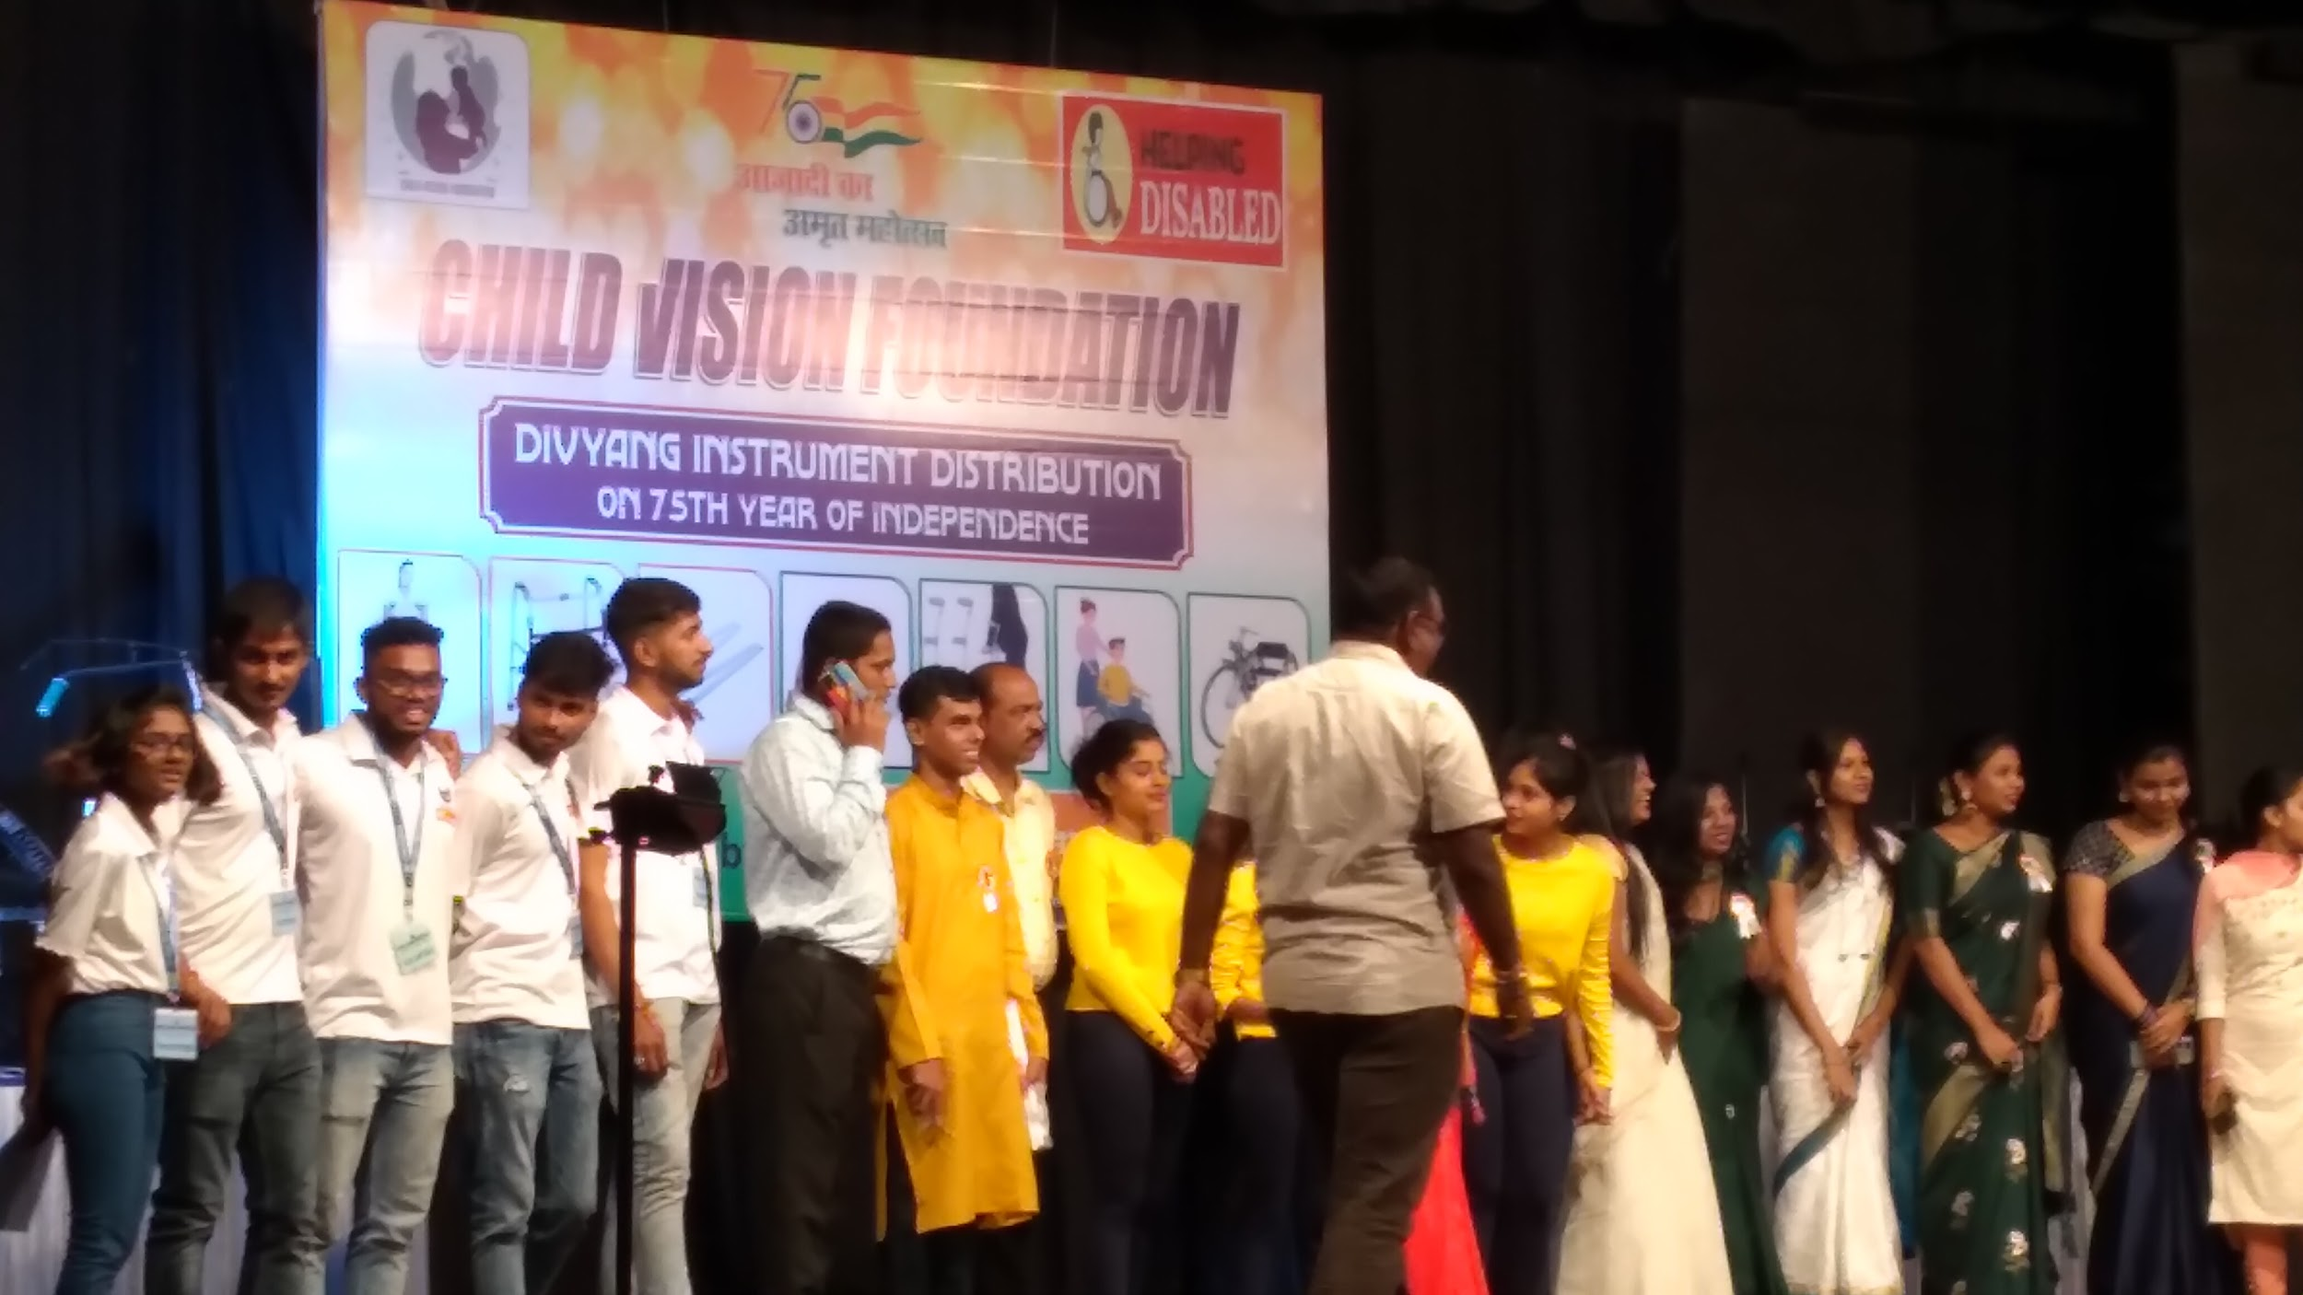

Through this event we learned various aspects of event management and how proper communication and coordination among teams is crucial for smooth functioning of an event. Most importantly, this event gave us a chance to help our society and has motivated us to work on societal problems with the simple belief that “you can work on something that doesn’t benefit you alone”.

## Day 5 : Aug 23, 2022 2:00 pm to 5.30 pm [3:30 Hrs]

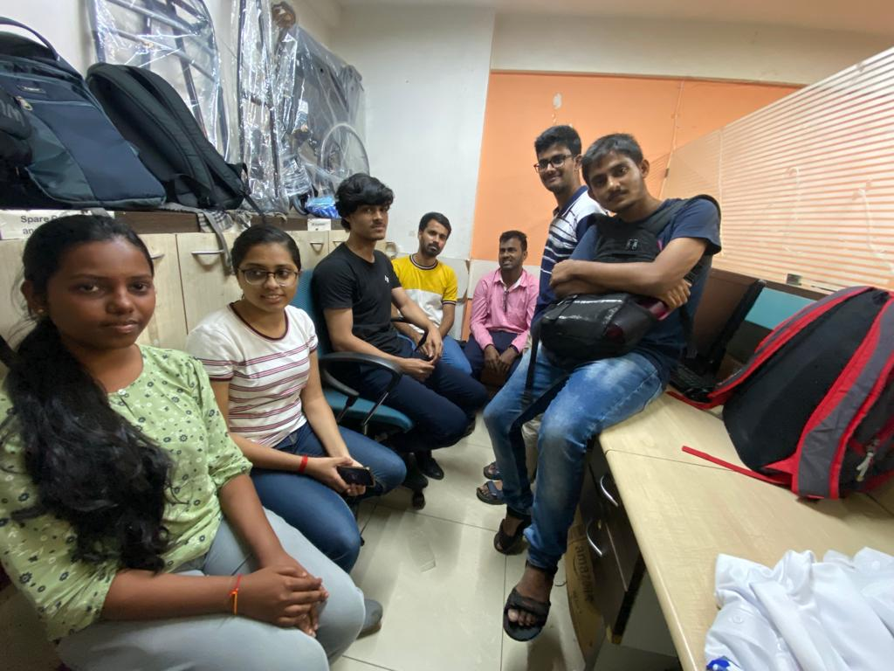

The Day fifth at the NGO had a meeting about the Event “HELPING DISABLED” feedback and learning.We had discussion on the topics like managing the crowd and handling the event.

We discussed the problems faced during the Event “HELPING DISABLED” for example We had designed a work allotment map of working the volunteers but during the event all the things were not as per the actual planning .we changed the work allotment map by seeing the requirements at different locations at the auditorium.

We also shared the key takeaways from the events like managing the crowd and the importance of teamwork in the event .We had discussed core steps to plan an event and gone through the detailed analysis of managing the event. At the end we had submission of shirts and id cards allotted by the child vision foundation.

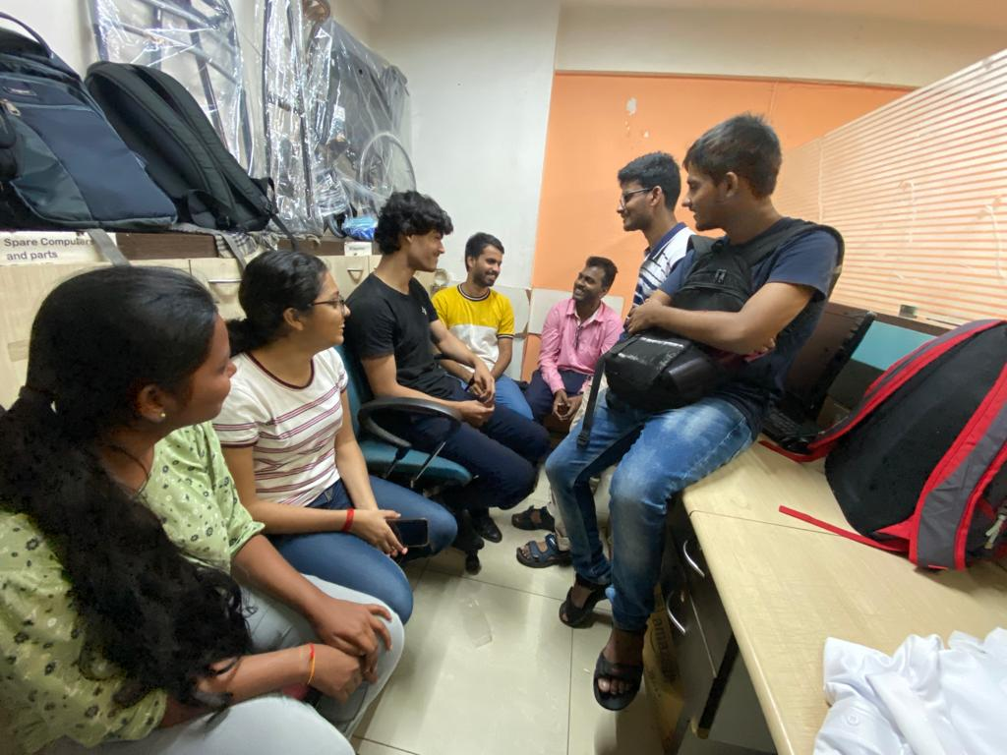

## Day 6 : Sep 18, 2022 2:00 pm to 5.30 pm [3:30 Hrs]